**Foodprint**

**Understanding Connections Between Food Choices and the Environment**

**Prof. Jennifer Jay**

**Chapter 8**

**Antibiotic Resistance and Agriculture**

**Section 1. Learning Outcomes**

By the end of this chapter, you will be able to:

* Discuss the importance of antibiotic resistance as a global challenge
* Discuss the various ways that antibiotic resistance genes are shared among bacteria, both of the same and different species.
* Understand current uses of antibiotics and the trends we are observing in their use.
* Discuss impacts of environmental antibiotic resistance on humans.
* Discuss trends observed for antibiotic resistance genes in the environment in CA.

**Section 2. Chapter Overview**

After an introduction to the challenge of rising levels of antibiotic resistance, we will discuss the ways in which antibiotic resistance genes can be shared among bacteria. We then briefly touch upon current uses and trends in use for antibiotics, and the development of new antibiotics. We then discuss the impact of antibiotic resistance in the environment on human health and we will look at some data for California on antibiotic resistance genes.

**Section 3. Introduction**

The development of antibiotics over the 20th century lead to *incredible improvements in medical care.*  We take for granted that infections such as those resulting from small surgeries, etc. will be treatable.

However, increasing microbial resistance to our antibiotics is now a worldwide threat to public health. Certain once-lifesaving drugs are now thought to be “worthless” (Woolhouse & Farrar, 2014), and development of new antibiotics has slowed dramatically in recent decades. Thus, it is critical to extend the useful life of the drugs on which we currently rely.

According to some estimates, antibiotic resistance already accounts for at least 700,000 lives lost per year globally (J. O’Neill, 2014; J. I. O’Neill, 2016), and if levels of antimicrobial resistance keep rising, there could be up to 10 million deaths per year by 2050. Recent cases of multi- and pandrug-resistant bacteria are causing concern about our ability to treat common bacterial infections (Liu et al., 2016; Olaitan et al., 2015).

Over time, bacteria “figure out” how to resist antibiotics. For example, they may be able to encode a gene that can alter the antibiotic so it doesn’t function anymore, export it out of the cell, or block its entry into the cell.

**Section 4. Proliferation of antibiotics in the environment**

The ability to resist an antibiotic can start out only in a particular bacterial cell, but the resistance can then proliferate because that cell has a survival advantage in the presence of the antibiotic. For example, in the picture below, only the purple cell on the left is able to resist the antibiotic. Once the drug is applied, all of the yellow cells are killed, leaving just the purple one to reproduce. The panel on the right shows the population after the purple cell has reproduced. The ability to resist the antibiotic, encoded by an antibiotic resistance gene (ARG), has been passed on by what is called vertical gene transfer, because the transfer happens between generations.

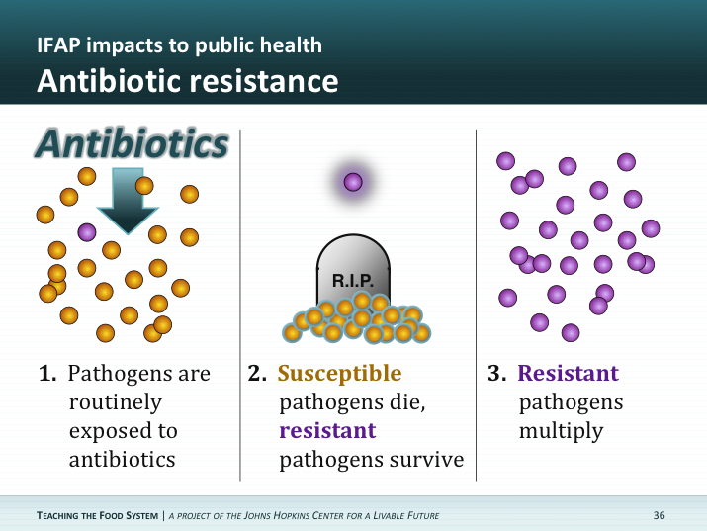

In addition to being passed by vertical gene transfer, ARGs can be passed from cell to cell by horizontal gene transfer (HGT. This can occur in various ways: 1) the cells may actually come into contact with each other and genetic material can travel from one to the other (conjugation), 2) free DNA in the environment that came from one cell at some point can be taken up by a new cell (transformation), and 3) viruses can “package up” bits of DNA and play a role in transferring that DNA between cells (transduction).

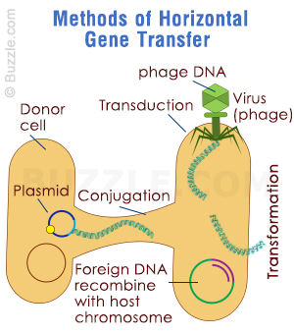

The level of antibiotic resistance observed in bacteria worldwide is rising. This is a problem, because we need our current arsenal of antibiotics to work against disease-causing organisms, called pathogens.

In fact, the CDC and the World Health Organization are extremely concerned about the level of proliferation of ARGs we are seeing. According to the World Health Organization, antibiotic resistance “*threatens the achievements of modern medicine*.”

**Section 5. Current Uses of Antibiotics**

Because use of antibiotics leads to eventual resistance, it is important to know how and why we use antibiotics. According to the Johns Hopkins Center for a Livable Future, approximately 3.3 million kg are used per year in human medicine. Use in humans is typically regulated by a doctor, and is prescribed to treat infections at “therapeutic doses,” which are designed to not result in proliferation of resistance. However, 13 million kg are used in animals, and the purpose here is to promote growth as well as treat infections. Thus, much of these drugs are given at “subtherapeutic doses,” which can give an advantage to bacteria containing resistance genes. The presence of low amounts of antibiotic results in a “selective pressure,” meaning it will select for (or give an advantage to) bacteria that are able to resist the antibiotic.

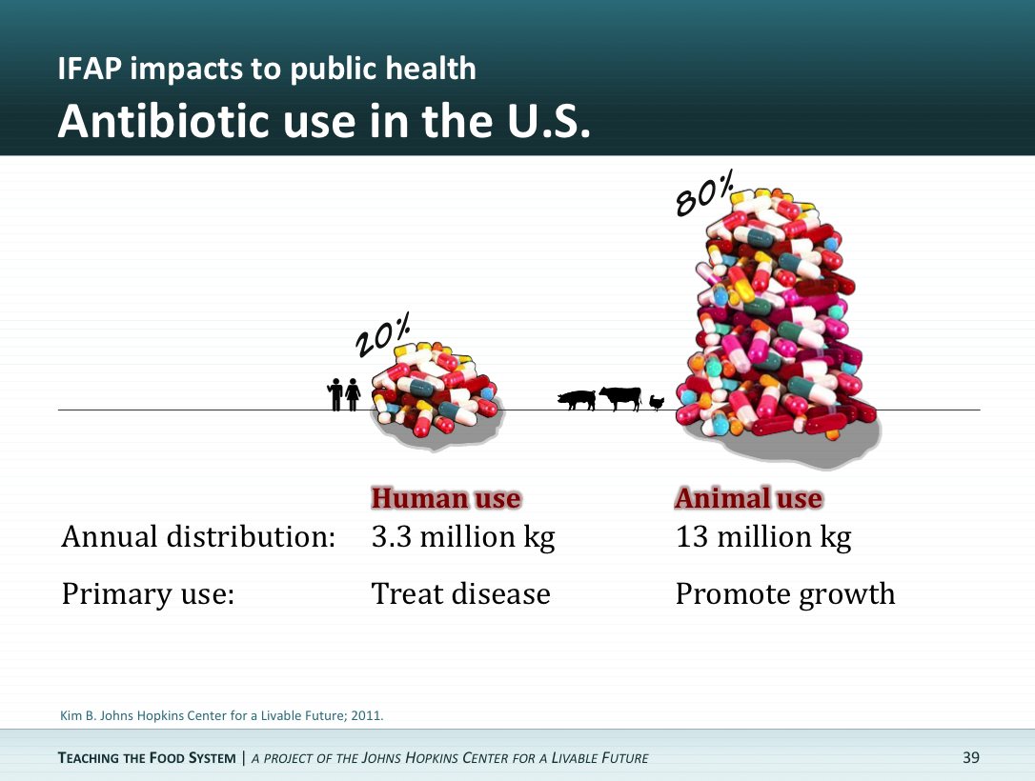

**Section 6. Trends in medical antibiotic use.**

* Medical antibiotic use (MAU) increased 36% from 2000-2010
* Carbapenems, a last-resort class (meaning doctors try to hold back on use of these drugs so that they are only used when really needed), increased 45%
* Most increase occurred in countries with little regulation. In areas of the world where infrastructure providing clean water may be lacking, antibiotics may be available over the counter.

Animal antibiotic use

* Agricultural antibiotic use (AAU) has also dramatically increased
* Selective pressure occurs in livestock
* > 90% of manure disposed by land application

There are two categories of antibiotics used in animal agriculture: ionophore and nonionophore. Ionophores are primarily used to increase feed efficiency and are not used in human medicine at this time. They work by transporting cations and other small molecules across biological membranes, which disrupts the import cation gradient that typically exists across the membrane. This stops growth of bacteria and fungi and can kill the cells. Nonionophores used in agriculture are also frequently used to increase feed efficiency by a number of different mechanisms and are often the exact same drugs used in human medicine. Some growth promoters work by changing the gut microbiome in the animal. Suppressing the typical non-pathogenic bacteria can lead to a more absorptive intestinal lining and greater weight gains. Also, infection due to intense confinement may be minimized through nonionophore use.

**Section 7. Development of new antibiotics.**

While it would be nice to think that we can easily keep up with antibiotic resistance by coming up with new drugs, the evidence shows that this cannot be relied on.

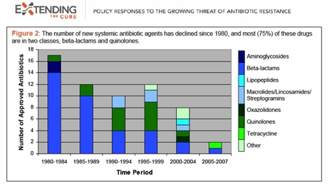

This graph shows that since 1980, the number of new antibiotics developed has steadily declined. The reasons for this may be a mix of economic (it is very expensive to develop new drugs) and scientific (there are only a certain number of ways to kill an organism) factors.

**Section 8. Impacts of agricultural antibiotics use on human health**

Antibiotics used for human medicine are sorted into classes by their chemical similarity and mode of action. Importantly, most classes have one or more drugs that are approved for use in animals. Resistance mechanisms can be sorted into groups of intrinsic and acquired; the proliferation of the latter is more of a concern for human health. Acquired resistance mechanisms can be further broken down into four types of modes of actions: prevention of access for the antibiotic to the target, modification of the target, protection of the target from the drug, and modification of the drug. Prevention of access to the target can be attained through both reducing permeability for the drug into the cell and increasing efflux of the drug out of the cell. Because membrane channels and efflux pumps can be effective across classes of antibiotics, these mechanisms can lead to multi-drug resistance.

Animal to human transfer of antibiotic resistant pathogens and antibiotic resistance genes can occur via:

**Direct transmission**. Antibiotic resistant bacteria associated with animals can be transferred directly to animal handlers and slaughterhouse workers. There are documented cases of this type of transfer vancomycin-resistant enterococci from hens to poultry farmers in the Netherlands (Andersson and Hughes, 2011), of fluoroquinolone-resistant *Escherichia coli* to poultry farmers (van den Bogaard et al. 2001), and of MRSA transmission to pig farmers (Voss et al. 2005).

**Environmental contamination.** Antibiotic resistant bacteria may travel off farms into the surrounding environment, where it can subsequently impact human health. For example. proximity to manured fields and livestock has been associated with increased infection with MRSA.

**Commercial food supply**. Foodborne pathogens such as *Salmonella* that acquire antibiotic resistance can pose great threats to people.

The graph below (from Silbergeld, 2008) shows that as fluoroquinolones were licensed for use in poultry and livestock, the percentage of clinical isolates of the pathogen *Campylobacter jejuni* that were resistant to these drugs increased.

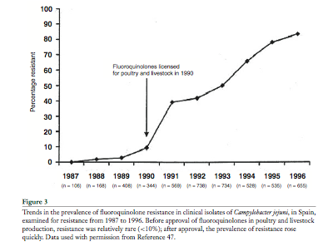

The next graph (Dutil et al. 2010) shows that after a voluntary withdrawal of an antibiotic, the percent resistance decreased dramatically. If the gene providing resistance is not needed for survival, the “cost” of carrying it (called a fitness cost) may make it favorable for the bacteria to lose the gene. This is encouraging, because it indicates that antibiotic resistance proliferation can in some cases be slowed or even reversed. However, other evidence shows that the fitness cost of carrying genes can sometimes be negligible.



**Section 9. Antibiotic resistance in the environment**

Recent work has identified the importance of environmental compartments in the movement of ARGs. Aquatic systems (Baquero, Martínez, & Cantón, 2008; Marti et al., 2014; Martins, Zanetti, Pitondo-Silva, & Stehling, 2014; Pruden, Arabi, & Storteboom, 2012; Storteboom, Arabi, Davis, Crimi, & A, 2010), biofilms (Engemann, Keen, Knapp, Hall, & Graham, 2008; Schwartz, Kohnen, Jansen, & Obst, 2003), and aquatic sediments (Chen, Liang, Huang, Zhang, & Li, 2013; Cummings et al., 2011; Yang et al., 2013) can all serve as important reservoirs for ARG, especially near agriculture (Pruden et al., 2012). ARB can travel via air (Chapin, Rule, Gibson, Buckley, & Schwab, 2005; Gibbs et al., 2006; Rule, Evans, & Silbergeld, 2008), and our recent work in this area is described below. Transport via air or water can mobilize ARGs to other areas where selective and co-selective processes have the potential to further increase ARG levels.

There are several routes by which an increased environmental reservoir of antibiotic resistant bacteria (ARB) and ARGs can impact human health. One way is through human exposure to antibiotic resistant zoonotic pathogens (not adapted for human-to-human transmission) (Chang, Wang, Regev-Yochay, Lipsitch, & Hanage, 2014; Mcewen, 2012; Travers & Barza, 2002). Known occurrences of direct transfer of zoonotic pathogens include the millions of cases of food-borne gastrointestinal illnesses that result from pathogens including *Salmonella* and *Campylobacter* each year (Scallan et al., 2011). In such cases, the illness is self-limiting due to the lack of human-to-human transfer. In contrast, ARGs can also be transferred to bacteria that are capable of human-to-human transmission. Some bacteria, such as vancomycin-resistant enterococci (VRE) can serve as pathogens in both animals and humans, and once they cross the species barriers can result in sustained illness in humans (Lipsitch, Singer, & Levin, 2002). However, even non-pathogenic bacteria originating in animals can be a source of ARGs in the human microbiome that may subsequently be passed among species.

Recent work in our lab (by Sanchez et al. (2016)) compared antibiotic resistant bacteria and ARGs in air samples collected near feedlots and organic cattle farms. Three farms of each type were sampled, and from each site, 200 different bacteria from the air collected from each site (1200 in total) were purified and tested individually for resistance to a suite of antibiotics. In general, greater resistance was observed in bacteria isolated from feedlots versus organic farms.



In a study of the resistome (which is the collection of ARGs in a particular location) in public parks in four California cities, we recently observed dramatic city-to-city differences for *bla*SHV levels in soils, with Bakersfield having the highest levels (Figure 1) (Echeverria-Palencia et al., 2017). Surprisingly, Fresno soil levels for the same gene were quite low, even though both are home to much agricultural activity. For drinking water available at parks, San Diego and Los Angeles had more consistently detected and higher levels of *bla*SHV and *sul*1, respectively (Figure 2). In general, drinking water variability was quite high, which is both expected and difficult to elucidate given the complex and dynamic sourcing of drinking water.

**Figure 1 | *bla*SHV ARG quantities in California soils.** SoilARG gene copy numbers across 24 parks in four California cities. Error bars denote intra-park variability when averaged over three sampling triplicates. *bla*SHV copy numbers normalized to per gram of soil. (Echeverria-Palencia et al., 2017)

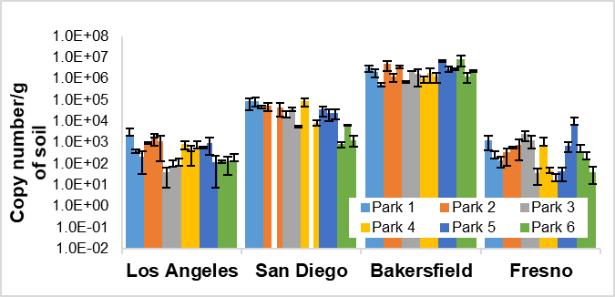

**.**

**Figure 2 | *bla*SHV ARG quantities in California tap water.** Tap waterARG gene copy numbers across 24 parks in four California cities. Error bars denote intra-park variability when averaged over three sampling triplicates. **(a)** *bla*SHV copy numbers normalized to per liter of water **(b)** *sul*1 copy numbers normalized to per liter of water. (Echeverria-Palencia et al., 2017)

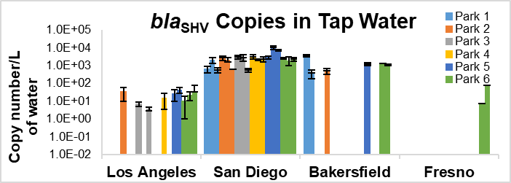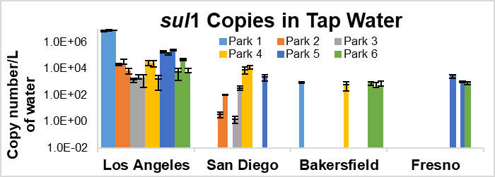

**a.**

**b.**

Section 10. Cited References

Baquero, F., Martínez, J.-L., & Cantón, R. (2008). Antibiotics and antibiotic resistance in water environments. *Current Opinion in Biotechnology*, *19*(3), 260–265. https://doi.org/10.1016/j.copbio.2008.05.006

Chang, Q., Wang, W., Regev-Yochay, G., Lipsitch, M., & Hanage, W. P. (2014). Antibiotics in agriculture and the risk to human health: how worried should we be? *Evolutionary Applications*, (Levy 1997), n/a-n/a. https://doi.org/10.1111/eva.12185

Chapin, A., Rule, A., Gibson, K., Buckley, T., & Schwab, K. (2005). Airborne multidrug-resistant bacteria isolated from a concentrated swine feeding operation. *Environmental Health Perspectives*, *113*(2), 137–142. https://doi.org/10.1289/ehp.7473

Chen, B., Liang, X., Huang, X., Zhang, T., & Li, X. (2013). Differentiating anthropogenic impacts on ARGs in the Pearl River Estuary by using suitable gene indicators, *7*.

Cummings, D. E., Archer, K. F., Arriola, D. J., Baker, P. A., Faucett, K. G., Laroya, J. B., … Zuill, D. E. (2011). Broad Dissemination of Plasmid-Mediated Quinolone Resistance Genes in Sediments of Two Urban Coastal Wetlands, *45*(2), 447–454.

Dutil et al. (2010) Ceftiofur resistance in *Salmonella enterica* serovar Heidelberg from chicken meat and humans, Canada. Emerging Infectious Diseases. 16(1): 48-54.

Echeverria-Palencia, C. M., Thulsiraj, V., Tran, N., Ericksen, C. A., Melendez, I., Sanchez, M. G., … Jay, J. A. (2017). Disparate Antibiotic Resistance Gene Quantities Revealed across 4 Major Cities in California: A Survey in Drinking Water, Air, and Soil at 24 Public Parks. *ACS Omega*, *2*, 2255–2263. https://doi.org/10.1021/acsomega.7b00118

Engemann, C., Keen, P., Knapp, C., Hall, K., & Graham, D. (2008). Fate of Tetracycline Resistance Genes in Aquatic Systems : Migration from the Water Column to Peripheral Biofilms. *Environmental Science & Technology*, *42*(14), 5131–5136.

Gibbs, S. G., Green, C. F., Tarwater, P. M., Mota, L. C., Mena, K. D., & Scarpino, P. V. (2006). Isolation of Antibiotic-Resistant Bacteria from the Air Plume Downwind of a Swine Confined or Concentrated Animal Feeding Operation. *Environmental Health Perspectives*, *114*(7), 1032–1037. https://doi.org/10.1289/ehp.8910

Lipsitch, M., Singer, R. S., & Levin, B. R. (2002). Antibiotics in agriculture: when is it time to close the barn door? *Proceedings of the National Academy of Sciences of the United States of America*, *99*(9), 5752–5754. https://doi.org/10.1073/pnas.092142499

Liu, Y. Y., Wang, Y., Walsh, T. R., Yi, L. X., Zhang, R., Spencer, J., … Shen, J. (2016). Emergence of plasmid-mediated colistin resistance mechanism MCR-1 in animals and human beings in China: A microbiological and molecular biological study. *The Lancet Infectious Diseases*, *16*(2), 161–168. https://doi.org/10.1016/S1473-3099(15)00424-7

Marti, R., Tien, Y.-C., Murray, R., Scott, A., Sabourin, L., & Topp, E. (2014). Safely coupling livestock and crop production systems: how rapidly do antibiotic resistance genes dissipate in soil following a commercial application of swine or dairy manure? *Applied and Environmental Microbiology*, *80*(10), 3258–3265. https://doi.org/10.1128/AEM.00231-14

Martins, V. V., Zanetti, M. O. B., Pitondo-Silva, A., & Stehling, E. G. (2014). Aquatic environments polluted with antibiotics and heavy metals: a human health hazard. *Environmental Science and Pollution Research International*, *21*(9), 5873–5878. https://doi.org/10.1007/s11356-014-2509-4

Mcewen, S. A. (2012). Human Health Importance of Use of Antimicrobials in animals and its Selection of Antimicrobial Resistance. In *Antimicrobial Resistance in the Environment*.

O’Neill, J. (2014). Antimicrobial Resistance : Tackling a crisis for the health and wealth of nations. *Review on Antimicrobial Resistance*, (December), 1–16.

O’Neill, J. I. (2016). Tackling drug-resistant infections globally: final report and recommendations. The review on antimicrobial resistance., (May).

Olaitan, A. O., Thongmalayvong, B., Akkhavong, K., Somphavong, S., Paboriboune, P., Khounsy, S., … Rolain, J.-M. (2015). Clonal transmission of a colistin-resistant Escherichia coli from a domesticated pig to a human in Laos. *The Journal of Antimicrobial Chemotherapy*, 1–2. https://doi.org/10.1093/jac/dkv252

Pruden, A., Arabi, M., & Storteboom, H. N. (2012). Correlation Between Upstream Human Activities and Riverine Antibiotic Resistance Genes. *Environmental Science & Technology*, *46*, 11541–11549.

Rule, A. M., Evans, S. L., & Silbergeld, E. K. (2008). Food animal transport: a potential source of community exposures to health hazards from industrial farming (CAFOs). *Journal of Infection and Public Health*, *1*(1), 33–39. https://doi.org/10.1016/j.jiph.2008.08.001

Sanchez, H., Echeverria, C., Flores, A., Thulsiraj, V., Zimmer-Faust, A., Laitz, M., Healy, G., Mahendra, S., Paulson, S. E., Zhu, Y., Jay, J.A. (2016) Comparison of antibiotic resistance in airborne bacteria near conventional and organic beef production facilities in California, USA.Water Air and Soil Pollution, 227:280 DOI 10.1007/s11270-016-2979-8

Scallan, E., Hoekstra, R. M., Angulo, F. J., Tauxe, R. V., Widdowson, M. A., Roy, S. L., … Griffin, P. M. (2011). Foodborne illness acquired in the United States-Major pathogens. *Emerging Infectious Diseases*, *17*(1), 7–15. https://doi.org/10.3201/eid1701.P11101

Schwartz, T., Kohnen, W., Jansen, B., & Obst, U. (2003). Detection of antibiotic-resistant bacteria and their resistance genes in wastewater , surface water , and drinking water bio ¢ lms, *43*, 325–335.

Silbergeld, E., Graham, J., Price, L.B. (2008) Industrial food animal production, antibiotic resistance, and human health. Annual Reviews in Public Health. 29:151-16.

Storteboom, H., Arabi, M., Davis, J., Crimi, B., & A, P. (2010). Tracking Antibiotic Resistance Genes in the South Platte River Basin Using Molecular Signatures of Urban , Agricultural , And Pristine Sources. *Environmental Science & Technology*, *44*, 7397–7404.

Travers, K., & Barza, M. (2002). Morbidity of infections caused by antimicrobial-resistant bacteria. *Clinical Infectious Diseases : An Official Publication of the Infectious Diseases Society of America*, *34 Suppl 3*(Suppl 3), S131–S134. https://doi.org/10.1086/340251

Woolhouse, M., & Farrar, J. (2014). An intergovernmental panel on antimicrobial resistance. *Nature*, *509*, 5–7.

Yang, J., Wang, C., Shu, C., Liu, L., Geng, J., Hu, S., & Feng, J. (2013). Marine sediment bacteria harbor antibiotic resistance genes highly similar to those found in human pathogens. *Microbial Ecology*, *65*(4), 975–981. https://doi.org/10.1007/s00248-013-0187-2