Foodprint
Understanding Connections Between Food Choices and the Environment
Prof. Jennifer Jay

Chapter 6
Biodiversity Loss and Livestock

Section 1. Learning Outcomes

By the end of this chapter, you will be able to:

- Describe the two types of Biological Integrity in the planetary boundaries concept and the control variable for each.
- Identify the current status of the Biological Integrity boundary variables.
- List the main drivers of biodiversity loss.
- Discuss the role of livestock in three of these drivers: habitat loss, climate change, and invasive species.

Section 2. Chapter Overview

This chapter introduces the two types of biological integrity in the planetary boundaries concept and their current status. The main drivers of biodiversity loss are described, and the role of livestock in three of the major drivers is discussed.

Section 3. The Biological Integrity Planetary Boundaries

Biodiversity loss is one of the three planetary boundaries that are currently being exceeded. The extinction rate today is 100 to 1,000 times the background rate. Due to our actions, we are in the midst of the 6th mass extinction in the Earth’s history.

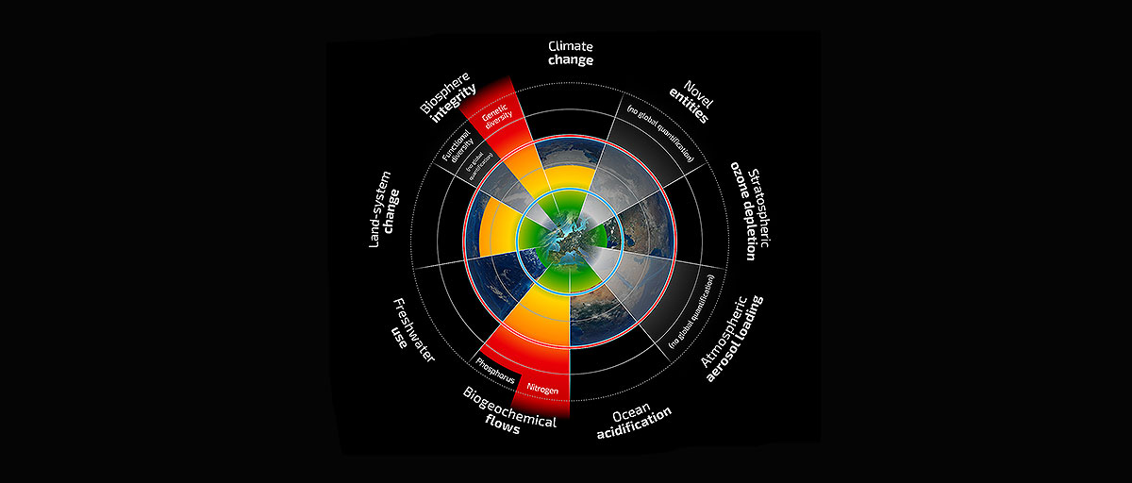
Figure 1. The Planetary Boundaries diagram.

For the process of Change in Biosphere Integrity, there are two categories, each with its own control variable and boundary. For genetic diversity, the control variable is the extinction rate. The boundary is set at <10 extinctions per million species per year (E/MSY), with the zone of uncertainty of 10-100 E/MSY. The background rate is approximately 1 E/MSY. We are currently greatly exceeding both this background rate and the planetary boundary with our current rate of 100-1000 E/MSY.

For functional diversity, the Biodiversity Intactness Index (BII) is the control variable. The planetary boundary recommends maintaining the BII at 90% or above, with the zone of uncertainty from 90-30% or above, assessed by biomes or large functional groups. Our current level of BII is 84%, calculated for southern Africa only.

Section 4. Main drivers of biodiversity loss

The main causes of biodiversity loss are:
- Habitat change
- Climate change
- Pollution
- Invasive species
- Overexploitation

Section 5. Livestock’s role in the major drivers of biodiversity loss

What is livestock’s role in these drivers?

- What is livestock’s role in habitat change?

Habitat changes including not only destruction but also fragmentation and degradation are the major threat to biodiversity on a global scale. Livestock are a direct and dominant cause of habitat change, due to feed production, livestock production, and overgrazing.

The single most significant cause of habitat loss around the world is livestock (Machovina et al. 2015). Production of livestock—including cultivation of feed crops-- is the largest single use of land by humans. According to the U.N., livestock production accounts for 70% of all agricultural land and 30% of the (ice-free) land surface of the planet.

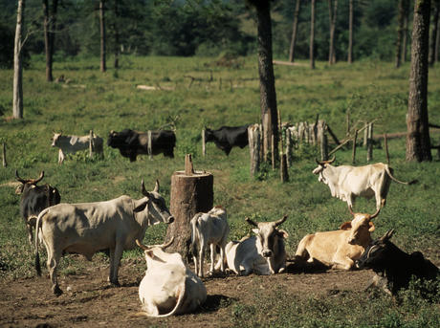
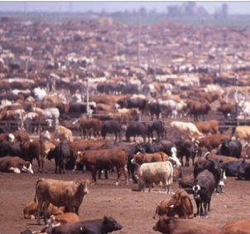
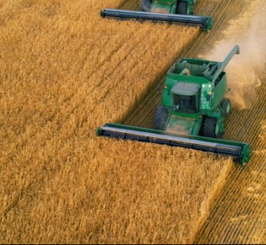

Overgrazing
Livestock land
Feedcrop production

Figure . Source: Pearson

Livestock production in Latin American is currently resulting in much deforestation. Cattle are grazing on former forests, and rainforests are biodiversity hotspots. Development is occurring in a diffuse manner, so the landscape is being fragmented. This causes increased habitat destruction, because areas bordering a developed area are also impacted. This is called an “edge effect.” Some land conversion is toward pasture land, and an increasing amount of cropland is being created for corn and soy to be used as animal feed.

Livestock vary in how much grain is required to yield a certain amount of meat. For example, to produce a pound of meat, chickens require 2 pounds of grain, pigs require 4 pounds of grain, and beef cattle require pounds of grain.

Rangeland has a capacity for ruminants, and if that is exceeded, the land is degraded and new land must be converted to pasture.
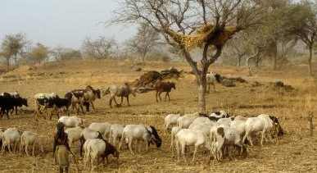

Figure . Source: Pearson

Slash and Burn agriculture is the term used to describe a situation where land is cleared for agriculture, but then has limited productive life, and new land must subsequently be cleared.

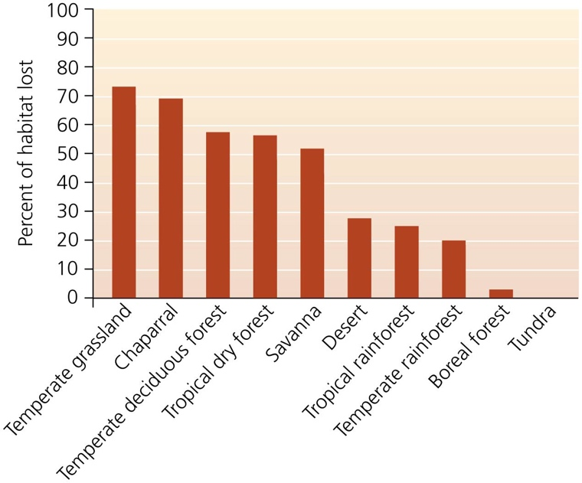

Figure . Source: Pearson

- What is livestock’s role in climate change?

Livestock are a major source of greenhouse gases due to cattle belching of methane, manure release of methane and nitrous oxide, and feedcrop production.

Crop production today requires a great deal of fossil fuel input. For example, N fertilizer production by the Haber-Bosch process is extremely energy intensive.

How does climate change affect biodiversity?

- Range of many species will move poleward or upward
- Species with limited ranges or limited geographical opportunities (such as mountaintop species) will go extinct
- Increased disturbances will result in changes in plant and animal assemblages.
- Coral reefs, mangroves, high mountain ecosystems, native grasslands, and ecosystems overlying permafrost are particularly vulnerable.
- Phenology

The effects of habitat loss and climate change are related, as climate change is a driver of habitat loss.

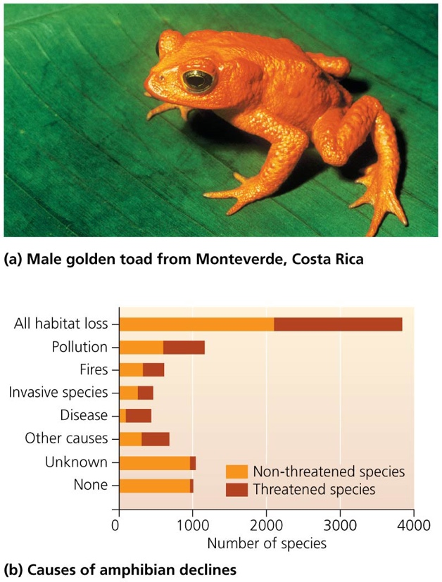

Figure . Source: Pearson

- What is livestock’s role in invasive species?

- Livestock are invasive species
- Animal production can facilitate invasive plant species (on grasslands, for example)
- Feral goats and pigs have decimated ecosystems on small islands
- Livestock contribute to seed dispersal

Section 6. Reducing livestock’s role in biodiversity loss

- Restoration of degraded land
- Reduction in animal product demand-- Vision of Impossible Burger, Beyond Burger etc. is to fill consumer demand for beef, but make it out of plants.
- Dietary shifts away from ruminant animals in particular
- Efficient food systems requiring less land
- Farming methods that integrate the natural environment and allow natural habitat
  - Swales
- Protective barriers of aquatic systems—natural buffer zones along rivers

Section 7. Cited References

Machovina et al. (2015) Biodiversity conservation: The key is reducing meat consumption. Science of the Total Environment. 536: 419-431.

Rockstrom et al. (2009) A safe operating space for humanity. Nature. 461:472-475.

Steffen et al. (2015) Planetary boundaries: Guiding human development on a changing planet. Science. 347, 1259855.

