**Foodprint**

**Understanding Connections Between Food Choices and the Environment**

**Prof. Jennifer Jay**

**Chapter 1**

**Food and the Planetary Boundaries**

**Section 1. Learning Outcomes**

By the end of this chapter, you will be able to:

* Discuss the planetary boundaries framework as a way to understand our impact on the Earth that takes into account absolute sustainability.
* Describe what is shown in the planetary boundaries diagram.
* Discuss how the diagram has changed since the time it was developed.
* List which three boundaries were exceeded when the diagram was created and which four are currently exceeded.
* Discuss how food systems are connected to many of the boundaries.
* Describe the recently proposed planetary health diet.

**Section 2. Chapter Overview**

This chapter gives in introduction to the planetary boundaries concept and how it has changed through time. Then, the interconnectedness with our food choices is discussed briefly boundary by boundary. The planetary health diet, proposed to feed 10 billion people healthfully within the planet’s limits, is presented. The ability of various combinations of food-related interventions (including diet shifts, food waste reduction, and production technolgoyu improvements) to achieve sustainability targets is discussed.

**Section 3. Introduction to the Planetary Boundaries Concept**

Throughout the Earth’s history, there is only one time period, the Holocene epoch, in which the conditions on Earth could support modern society. The Earth has been in a Holocene state for the last 11,700 years, and during that time, human civilization has flourished. Our increasing impact on the natural processes critical to functional in the biosphere are now threatening the very stability of these favorable conditions.

The planetary boundaries concept provides a useful way to think about how our actions impact the Earth. It proposes a set of guidelines that put limits on our alterations of natural processes. This concept fills an urgent need for a framework to convey an understanding of both the many processes on Earth that must be maintained in order to have a healthy biosphere and the role our activities play in them.

For each of the processes identified in the planetary boundaries concept, one or more control variables have been identified that give information on the degree to which we have disrupted that system. For example, for the process of Climate Change, the control variables are atmospheric CO2 concentration (ppm) and energy imbalance at the top of the atmosphere (W/m2). For the process of Change in Biosphere Integrity (categorized as Rate of Biodiversity Loss in the 2009 version), there are two control variables: extinction rate for genetic diversity, and Biodiversity Intactness Index (BII) for functional diversity. These two processes, Climate Change and Biosphere Integrity, have been identified as core boundaries due to their significant roles in the Earth system.

While monitoring the current status of the control variables gives an estimate of our impact on a particular process, the planetary boundary concept also provides recommended limits on those control variables. For example, the planetary boundaries for climate change are a concentration of CO2 in the atmosphere of 350 ppm (with a zone of uncertainty from 350-350 ppm) and an energy balance at the top of the atmosphere of 1.0 W/m2 (with a zone of uncertainty of 1-1.5 W/m2. Our current status for these control variables is 398 ppm CO2 and 2.3 W/m2 (with a zone of uncertainty from 1.1-3.3 W/m2).

The planetary boundaries point us toward the environmental issues that are most urgent to address if we are to continue to have a stable biosphere. Each section of the diagram is actually a graph representing increasing disruption of that particular environmental process

moving outward from the center of the circle. In each section of the graph, the zone within the blue circle, depicted in green, shows the “safe operating space for humanity,” and the red represents the disruption of that process if we maintain the status quo. The yellow zone shows the region of uncertainty, and the red zone is beyond the upper limit of uncertainty.

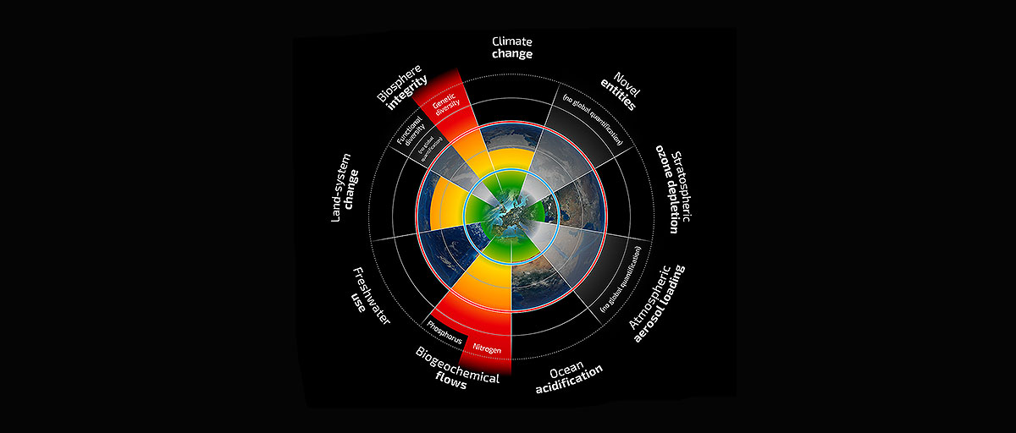

Figure 1. The Planetary Boundary Diagram. Each slice of this graph shows the status of a control variable associated with each process identified to be critical for Earth system functioning. The green area in each section represents a “planetary boundary,” which is a level of disruption that we should not exceed. The red depicts how our current actions are impacting each process. Four boundaries have been exceeded: climate change, nitrogen cycling, biodiversity loss, and land use change. (Steffen et al. 2015)

In the most recent version of the planetary boundary diagram, four boundaries have been exceeded: climate change, nitrogen cycling, biodiversity loss, and land use change.

Figure 2 shows the original planetary boundaries diagram, which illustrates the notion that by the time this concept was created, 2009, we were already exceeding sustainability limits for climate change, nitrogen cycling, and biodiversity loss. Thus, we see that this concept can be used through time to track our progress toward environmental sustainability.



## Fig. 2. The Original Planetary Boundaries Diagram

Each slice of this graph shows the status of a control variable associated with each process identified to be critical for Earth system functioning. The green area in each section represents a “planetary boundary,” which is a level of disruption that we should not exceed. The red depicts how our current actions are impacting each process. (Rockstrom et al., Nature 2009)

**Section 4. Food and the Planetary Boundaries**

Food systems are intimately linked with the planetary boundary processes, in particular the four that are now above sustainable limits of disruption. In this chapter, we will briefly discuss the ways the planetary boundaries are connected with food systems. Subsequent chapters will delve more deeply into the connections between food choices and certain planetary boundaries.

Climate change

Agriculture is responsible for a huge fraction of our greenhouse gas (GHG) emissions, with livestock alone contributing 14.5% (U.N. FAO), which is higher than all transportation combined. Foods vary in the amount of greenhouse gas emissions embodied in their production, processing, packaging, and transport (Heller and Keoleian, 2014). In general, foods higher on the food chain are more resource intensive because the animals require feed throughout their lives, and most of that energy goes to the metabolism of the animals. This means is takes much more energy to produce a calorie of animal product than it does to produce a calorie of plant-based food. Certain animal products including beef, lamb, and dairy are particularly high in embodied greenhouse gas emissions because ruminant animals produce methane as part of their natural digestion processes. In Chapter 2, impacts of food production, food miles, packaging, refrigerated transport, refrigeration during retail, and waste will be discussed. GHGs associated with bottled water production and transport will also be covered.

Ocean acidification

Much of the carbon dioxide emitted into the atmosphere since the start of the Industrial Revolution has been absorbed into the oceans. While this has delayed to some extent the climate change we are experiencing due to GHGs in the atmosphere, carbon dioxide is changing the pH of the ocean. In fact, ocean acidification is sometimes called “the other carbon problem.” When a molecule of CO2 dissolves in water, it combines with a molecule of water, creating an acid called carbonic acid, or H2CO3. This chemical donates H+ to the water, which causes a decrease in pH. That decrease causes a reduction in the level of carbonate ions (CO32-) in the water, which is disruptive for organisms that depend on carbonate ions to build calcium carbonate shells.

Nitrogen and phosphorus cycling

This section of the course will review impacts of food systems on nitrogen and phosphorus cycling as well as the ramifications of nutrient cycle disruption for ecosystem and human health. Agriculture practices dramatically influence the nitrogen cycle. In fact, our ability to grow large amounts of crops during the Green Revolution was enabled by invention of the process to chemically convert nitrogen gas to ammonia, a usable form for plants. However, the energy required for this process results in significant GHG emissions. In addition, nitrous oxide from agricultural soil and manure is a potent GHG.

Nutrient pollution (including nitrogen (N) and phosphorus (P)) may be best known for its role in stimulating excess algal growth in aquatic systems. “Dead zones” where oxygen has been depleted (called hypoxia) can results through the decay of the algae. In addition, disruption of the N cycle has direct impacts on human health: nitrogen containing compounds in lower atmosphere leads to increased tropospheric ozone, smog, particulate matter; increased ozone leads to increased asthma and premature death; and nitrate pollution of drinking water is a major problem.

Freshwater use and pollution

Water use is one of the planetary boundaries. Too much manipulation of the freshwater cycle can result in negative impacts on biodiversity, food security, health security, the resilience of ecosystems, and ecosystem services including habitat, carbon sequestration, and climate regulation. Currently 70% of our freshwater use goes to agriculture. The water footprint of a particular activity or food has three components: blue water (surface and groundwater), green water (water in unsaturated soil and plants), and gray water (water necessary for dilution of pollution to harmless levels). This chapter will describe the water footprint of different foods and the impacts on the environment from excessive use and pollution of freshwater.

Landuse change and Biodiversity loss

Biodiversity loss is one of the three planetary boundaries that are currently being exceeded. The extinction rate today is 100 to 1,000 times the background rate. Due to our actions, we are in the midst of the 6th mass extinction in the Earth’s history. One of the main causes of biodiversity loss is habitat change, and much of the land surface of the Earth is used for agriculture. According to the U.N., livestock production accounts for 70% of all agricultural land and 30% of the (ice-free) land surface of the planet. We will explore the land requirement for the current US diet, as well as various scenarios, and the consequent the impacts on biodiversity loss due to habitat change and fragmentation.

Chemical pollution

Agricultural practices often involve addition of chemicals such as herbicides and pesticides. These chemicals can affect worker health and can be transported offsite through surface water runoff, infiltration to groundwater, wind, and as residues on the products. In this section of the chapter, we will discuss impacts on workers, communities, and wildlife from agricultural chemicals in common use today and will compare organic and conventional production of various types of foods.

Use of antibiotics in agriculture

The development of antibiotics over the 20th century lead to *incredible improvements in medical care.*  After exposure to low levels of antibiotics, however, bacteria develop resistance to these drugs, and antibiotic failure due to increasing antibiotic resistance is currently a rising worldwide threat to public health. In fact, according to the World Health Organization, antibiotic resistance “*threatens the achievements of modern medicine*.” Over 75% of the antibiotics used today are for livestock, with the primary purpose to promote growth at low doses. It has been shown repeatedly that after particular antibiotics were licensed for use in poultry and livestock, the percentage of clinical isolates of the pathogen that were resistant to these drugs increased. Livestock workers have shown increased resistance to antibiotics, as have residents living near agricultural facilities using antibiotics.

**Section 5. The Planetary Health Diet**

In January 2019, an interdisciplinary Commission of 37 scientists from 16 countries proposed a “planetary health diet” designed to sustainably provide health diets to 10 billion people by 2050. While it is well-established that food systems play a critical role in both human and environmental health, the study posits that the lack of clear targets make progress difficult and sets out to propose them.

Willett et al**.** (2019) identified an optimal range of consumption of a set of food categories, based on health guidelines. Providing this planetary health diet to 10 billion people, along with waste reduction and technological improvements, can meet many of the planetary boundaries in 2050, according to the authors’ projects (details below).

Table 1. Planetary health diet proposed by Willett et al. (2019) for providing a healthy diet to 10 billion people by 2050 within the planetary boundaries.



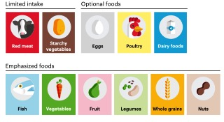

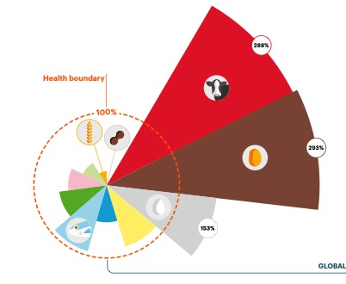

## Fig. 3. Current global diet in relation to health targets.

Each slice of this graph shows the status of the current global diet compared to health targets. The orange dotted line is planetary health diet target for each slide of the pie. Starting at the center of the circle, each wedge shows the consumption level for each food category. Colors corresponding to each food category are shown above the graph. (Source: Willett (2019) EAT-Lancet Summary)

Figure 3 depicts how the current global average diet compares to the planetary health targets. The global average red meat consumption, shown by the red wedge, is 288% of the health limit, or approximately 2.9 times greater. Starchy vegetables are also about 2.9 times greater than the limit. Notably, currently consumed levels of whole grains, nuts, vegetables, and fruits—all of which are generally acknowledged to be associated with health benefits—are below the target.

Willett et al. (2019) modeled how not only food demand shifts, but also decreases in food waste and improvements in production technology, can collectively help achieve planetary boundary targets. Table 2. shows the level to which various scenarios of food-related interventions are in compliance with the planetary boundaries. The top four rows are for business as usual with respect to production technology, and within those four rows, the top two are without a modeled decrease in food waste while the bottom two model half waste. Then, within each group of two, the top row models business as usual diets while the bottom models the planetary health diet.

Notably, for greenhouse gas emissions, diet change shifts compliance from red to green regardless of the other factors. For land use, improvements in production will be required. For the planetary boundaries to the right of the table, nitrogen application, phosphorus application, and biodiversity loss, none of the scenarios has a green prediction.

Table 2. Source: Willett (2019) EAT-Lancet Summary

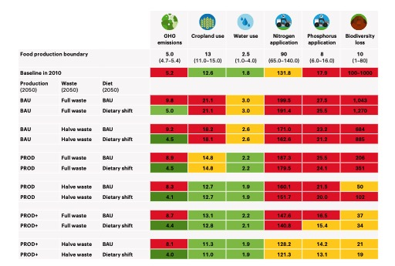

Figure 5 provides a visual representation of the compliance of various food-related interventions with the planetary boundaries. Each scenario is depicted by a wedge of a particular color in each section of the circle. For example, the modeled impact for just the planetary health diet alone and for a combination of approaches with high ambition can be seen in the maroon and dark teal wedges, respectively. The dark teal wedge is below or close to the boundary in all sections of the graph, indicating that a combined approach including but not limited to dietary shift is necessary for meeting targets. The exception is biodiversity loss, for which all scenarios are above the boundary. In this case, only the dark teal wedge is shown.

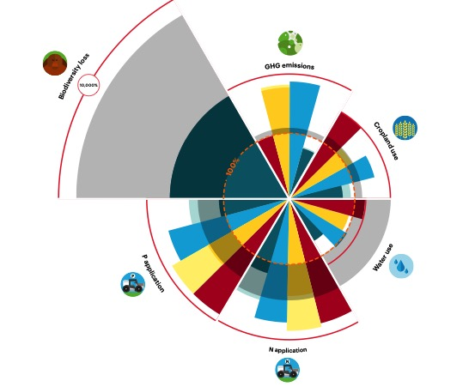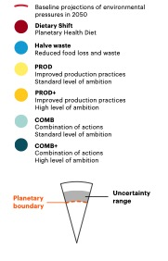

Figure 5. Impact of food-related interventions on compliance with

the planetary boundaries of GHG emissions, cropland use, water use, N application, P application and biodiversity loss.

**Section 4. Cited References**

Heller, M.C. and Keoleian, G.A. (2014) Greenhouse gas emission estimates of U.S. dietary choices and food loss. J. Industrial Ecology. 19(3)

Rockstrom et al. (2009) A safe operating space for humanity. Nature. 461:472-475.

Steffen et al. (2015) Planetary boundaries: Guiding human development on a changing planet. Science. 347, 1259855.

Food and Agriculture Organization (FAO). (2013) Tackling climate Change through Livestock. United Nations.

Willett (2019) Summary Report of the EAT-Lancet Commission

Willett et al. (2019). Food in the Anthropocene: the EAT-Lancet Commission on healthy diets from sustainable food systems. Lancet 393(10170):447-492.